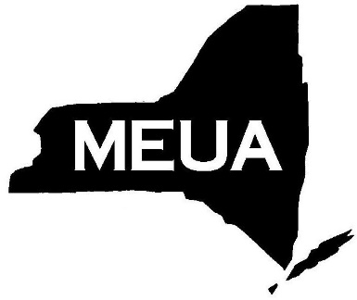
Municipal Electric Utilities Association of New York State
6652 Hammersmith Drive, East Syracuse, New York, 13057
Phone: 315-453-7851 Fax: 315-453-7849
Email: info@meua.org Website: www.meua.org

TO: Municipal Members
FROM: Narin Ly
DATE: November 27, 2019
RE: 2020 LINEWORKER SAFETY AND TRAINING PROGRAM REGISTRATION

Below is the 2020 registration form for the MEUA/NEPPA Lineworker Safety & Training Program. Please complete the form and return it to the MEUA offices as soon as possible or by January 31, 2019 at the latest.
Cost: $1,860.00 per student for the year for MEUA members and $2,710.00 per student for the year for non-members.
The January 2020 schedule with dates and locations is attached.
Please contact the MEUA offices if there are any questions.

2020 LINEWORKER SAFETY & TRAINING REGISTRATION: 8 Classes
Email/Fax registration form
info@meua.org or
315-453-7849

System_______________________________________________
Authorized Signature__________________________________
Name of Participant(s)
1. | 5. | 9.
2. | 6. | 10.
3. | 7. | 11.
4. | 8. | 12.

