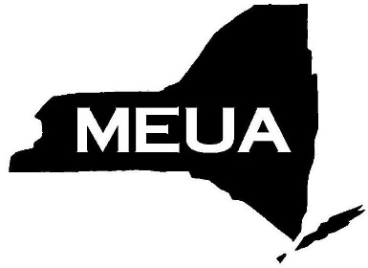
Municipal Electric Utilities
Association of New York State
6652 Hammersmith Drive, East Syracuse, New York, 13057
Phone: 315/453-7851 Fax: 315/453-7849
Email: info@meua.org web site: www.meua.org

What: Western Regional Conference Hosted by Village of Springville Electric
When: Wednesday, June 26, 2019
Where: UNOVA Coworking - (parking in the Village Public Safety lot at 65 Franklin St.)
29 Mechanic St
Springville, NY 14141
Phone for directions & info day of 716-592-4936 x1467 or 716-913-2302
Fee: $25.00 members $35.00 non-members

9:30 am-10:00 am Registration: Coffee and refreshments provided by Village of Springville

10:00am-10:45am Presenters: Introduction by Mayor Bill Krebs. Presentation by: Reed Braman, Director of Energy Development and Management for Erie County & Green Springville President.

11:00 am Golfers arrive at Golf Course for Lunch

12:00pm-5:00pm Golf: Concord Crest Golf Course – $20 per person CASH ONLY

11:00 am Non golfers tour of Concord Mercantile and Heritage Building then lunch on your own in historic downtown Springville.

1:00 pm -4:30pm Tour # 1: Springville Village downtown historic district shops, S. Cascade shops, Gentner’s Auction on W. Main St. and antique stores. (Walking & Driving).

1:00 pm -4:30 pm Tour # 2: Griffiths Sculpture Park tour & or Scoby Dam Hike. (Car pooling). Leave from 71 Nason.

3:30 pm-5:30 pm Fireman’s Park pavilion will be open with refreshments & for breaks. 71 Nason Blvd. (behind DPW)

5:30 pm-8:30 pm Reception & Casual Dinner: Jake and the Fat Man BBQ & Clams- Fireman’s Park 71 Nason Blvd – Casual Dress- Horse Shoes and Corn Hole. Speaker: Mayor Bill Krebs Music by Nick Kody

Accommodations: Microtel Inn & Suites by Wyndham 270 S. Cascade Dr. Springville 716-592-3141. Book early if you need a room. (Mention MEUA for a rate of $71.10 /night) rooms will be released by June 5th.
* * * * * * * * * * * * * * * * * * * * * * * * * * * * * * * * * * * * * * * * * * * * * * * * * * * * * * * * * *
MEUA Western Regional Meeting
The deadline to register for this event is:
June 13^{th,} 2019
Date: June 26, 2019
Host: Village of Springville Electric
Municipality/Company:
Name(s) of Attendees:

Sign up for
Activities
here

Golf | Tour #1 | Tour #2
Please submit this registration form via email info@meua.org or by Fax 315-453-7849
Payment by check must be sent to: MEUA
PO Box 387
MEUA does not accept credit card payments. Invoices will be sent to your inbox upon receipt of this form. Please submit your registration form via email or fax.
Solvay, NY 13209

