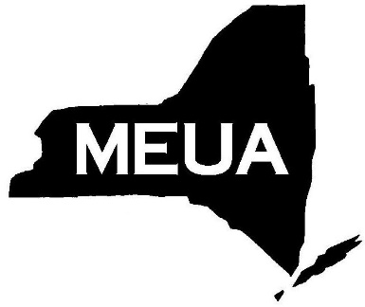
Municipal Electric Utilities
Association of New York State
6652 Hammersmith Drive, East Syracuse, New York, 13057
Phone: 315-453-7851 Fax: 315-453-7849
Email: info@meua.org Website: www.meua.org

Corporate Vendor Registration Form

What: 2019 November Engineering Workshop
When: Tuesday & Wednesday, November 5th & 6th
Hotel Accommodations

Embassy Suites by Hilton Destiny USA
$129.00 Single or Double Occupancy
Please call 315-303-1650
To receive the MEUA group rate, please reference the code MEUA.

Where: Embassy Suites by Hilton
Syracuse Destiny USA
311 Hiawatha Blvd W.
Syracuse, NY 13204

Please mark the appropriate boxes:

MEUA Member Pricing
- $80.00 Member Registration Fee (per person)
- $50.00 Corporate Member Display Table (per table)
Please submit your registration form via:

Email to: info@meua.org

Or

Fax: 315-453-7849

The deadline to register for this event is:

October 31st, 2019

Non-Member Pricing
- $150.00 Non-member Registration Fee (per person)
- $400.00 Corporate Display Table (per table)

Company

Attendees

All participants must register to attend. Invoices will be delivered to your inbox upon receipt of this registration form. Please make every effort to remit payment before the event date. MEUA does not accept credit card payments. Please send your payment via check or echeck to:

MEUA
Send payment to this address
P.O. Box 387
Solvay, NY 13209

