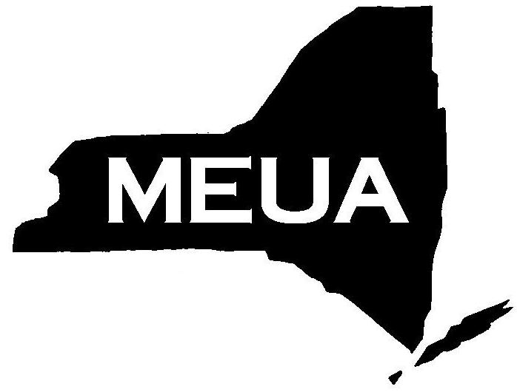
Municipal Electric Utilities
Association of New York State
6652 Hammersmith Drive, East Syracuse, New York, 13057
Phone: 315-453-7851 Fax: 315-453-7849
Email: info@meua.org web site: www.meua.org

What: Central Regional Meeting Hosted by The Village of Richmondville
When: Tuesday, June 11th, 2019
Where: Registration & Presentation at The Red Barn Clubhouse, 2322 Route 7, Cobleskill, NY
Fee: $40.00 members. $60.00 non-members.
9:30-10:00 am Registration: Coffee & Donuts
10:00-11:30 am Presentation: Rick Palumbo, Utility Software Acquisitions
11:30 am Lunch: On your own; nearby restaurants include Red Barn Clubhouse, Grapevine Farms, Pizza Shack, and Justine’s
1:00 pm Golf: Cobleskill Golf and Country Club at 2322 Route 7, Cobleskill, NY 12043
Cost: $34 per person (price includes cart rental)
-OR-
1:00 pm Tour: Secret Caverns at 671 Caverns Rd, Howes Cave, NY 12092
Please bring a jacket. (Free of charge; Shuttle not provided, 5 miles from The Red Barn Clubhouse)

6:00 pm Reception & Dinner: Red Barn Clubhouse
(Sliced Roast Beef & Chicken Marsala Buffet)

6:30 pm Dinner Speaker: Honorable Kevin P. Neary

Hotel Accommodations: Super 8 by Wyndam, 955 East Main St, Cobleskill, NY 12043
Rates as low as $96 per night.
* * * * * * * * * * * * * * * * * * * * * * * * * * * * * * * * * * * * * * * * * * * * * * * * * * * * * * * * * *
MEUA Central Regional Meeting
The deadline to register for this event is:
June 5, 2019
Date: June 11, 2019
Host: Village of Hamilton
Municipality/Company:
Name(s) of Attendees:

Golf | Tour
Sign up for
Activities
here

Please submit this registration form via email info@meua.org or by Fax 315-453-7849
Payment by check must be sent to: MEUA
MEUA does not accept credit card payments. Invoices will be sent to your inbox upon receipt of this form. Please submit your registration form via email or fax.
PO Box 387
Solvay, NY 13209

