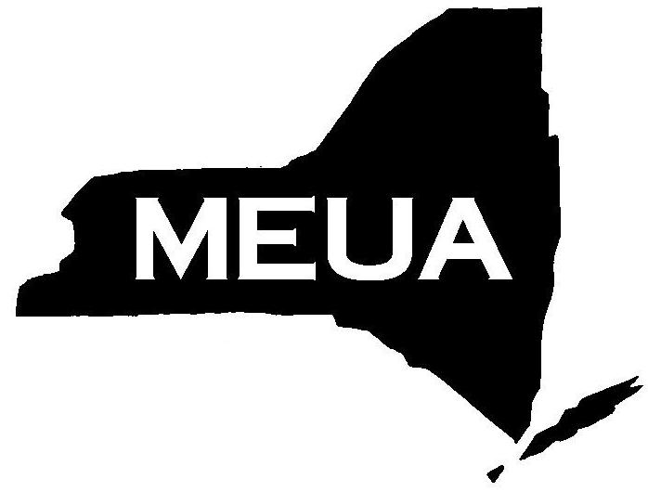
Municipal Electric Utilities
Association of New York State
6652 Hammersmith Drive, East Syracuse, New York, 13057
Phone: 315-453-7851 Fax: 315-453-7849
Email: info@meua.org Website: www.meua.org

TO: 2020 Apprentice Lineman

FROM: Narin Ly, MEUA Lineman Training Program

SUBJECT: Hotel Accommodations for the 2020 MEUA Apprentice Lineman Program in Fairport, NY

Location

Hampton Inn & Suites Victor
7637 Pittsford Victor Road | Victor, NY 14564
www.rochestersuites.hamptoninn.com
Phone: (585) 924-4400

The Wal-Mart Plaza located across the street, more than 20 restaurant & food options just within .5 miles of the hotel. Eastview Mall located just .25 miles from the hotel.

Meua Discounted Rate

January 1- December 31, 2020— Standard Guestroom @ $109 per night

(Taxes are currently, 10.5%. Rates are subject to hotel’s availability. Blackout dates may apply.)

Reservations

To make your reservations online please go to www.rochestersuites.hamptoninn.com and click add special rate codes then under Corporate Account, enter the MEUA Corporate ID code listed below.

MEUA Corporate ID Code: 0560075996

You may also call in to the reservations department at 800-426-7866 and request the hotel, Hampton Inn Victor Rochester and be sure to request the Municipal Electric Utilities Association Discounted Rate.

HOTEL FEATURES

The hotel offers a comfortable setting for your employees, such as:

- Newly Renovated Guestrooms (as of the winter 2018)
- 123 guest rooms total, including:
- 37 Standard Doubles and 26 Standard King Bedded rooms
- 12 Deluxe Double-bedded suites, 43 Deluxe King suite
- Suites include a separate living space with a wet bar that includes a refrigerator and microwave, dining room table and pull out sofa bed. Some suites have a fireplace as well!
- All Guest rooms include Hot Breakfast Daily!
- Complimentary High-Speed Internet Access
- Complimentary Shuttle Service
- To/From the NY Beer Project, the airport and within a 5-mile radius of the Hotel based upon availability
- On-Site Fitness Center, Pool, Hot Tub & Business Center
- Includes free weights, 2 ellipticals, 2 treadmills, 1 recumbent bike, yoga mats & ball
- Complimentary On-Site Self-Parking
- Complimentary Hot Coffee 24/7 & refreshed throughout the day
- On-Site Guest Laundry Facility
- To-Go Breakfast Bags available Sunday – Friday
- Popcorn & Cookies available in the lobby Sun - Friday

ADDITIONAL CONCESSIONS

- Complimentary suite upgrades offered based upon hotel’s availability
- Managers Reception every Wednesday 5:30-7pm
- Consists of Complimentary Hors d’oeuvres, Beer & Wine
- City Tavern Restaurant & Bar located in the same parking lot of the hotel
Offers 10% OFF to guests off all Food & Beverage



