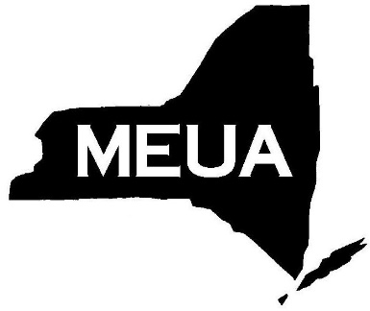
Municipal Electric Utilities
Association of New York State
6652 Hammersmith Drive, East Syracuse, New York, 13057
Phone: 315-453-7851 Fax: 315-453-7849
Email: info@meua.org Website: www.meua.org

TO: Member Systems
FROM: Narin Ly
DATE: December 6, 2019
RE: YEAR 2-4 LINEWORKER APPRENTICE PROGRAM REGISTRATION

Below is the 2020 registration form for your employee(s) who are currently in the Lineworker Apprentice Program (Year 2-4). Please complete the form and email or fax it to the MEUA offices as soon as possible. The deadline for registration is February 29, 2020.

As in the past, there will be four sessions of four days of class per session. Classes will be held from 8:00am to 2:00pm at Fairport Municipal Commission Operation Center in Fairport, NY. Please contact the MEUA offices if there are any questions.

Please list the names of your participating students, and if they will be completing either their 2nd, 3rd, or 4th year of the Apprentice Program in 2020:

Student Name | Year # (2, 3 or 4) | Notes
1.
2.
3.
4.
5.

System_________________________________________________

Authorized Signature____________________________________

